Report of “World Blood Donor Day – Rally”

On 14th June 2023, our SSMIET NSS wing took participation in “BLOOD DONATION AWARENESS RALLY” which was conducted by CF hospital, Oddanchatram. Around 20 NSS students, doctors of CF hospital and many nursing students participated in this rally. Our volunteers started our rally from CF Hospital at 9.00am. Our volunteers carried awareness boards to create awareness among people. Our volunteers reached the CF hospital by 10 am. The doctors explained the importance of blood donation. Finally volunteers reached our college by 11.00 am.

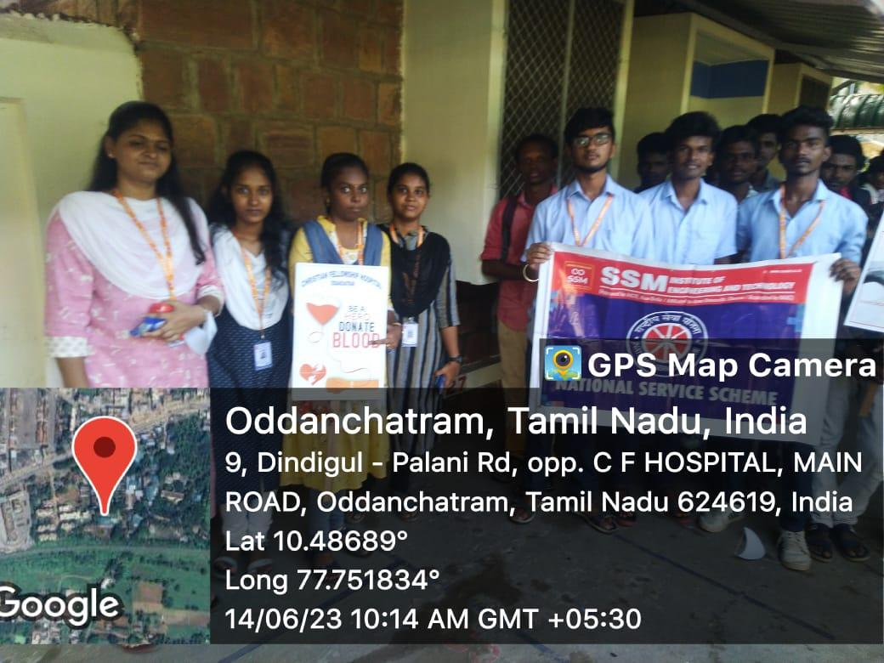 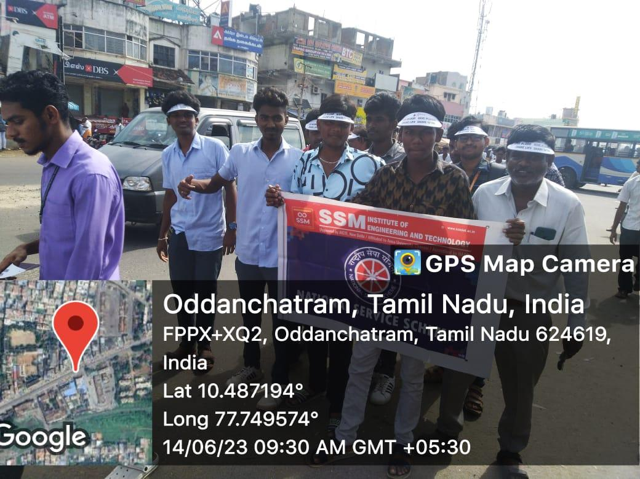

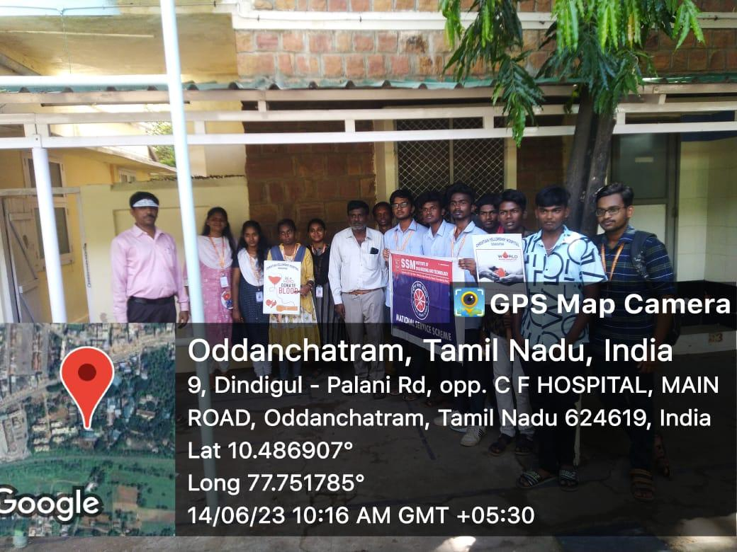

NSS Coordinator Principal